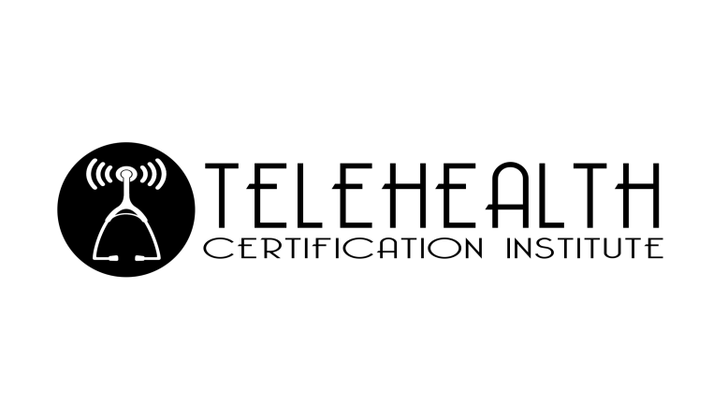

You can register and make payment by mailing in this form to:
Telehealth Certification Institute LLC
261 South Pearl Street
Canandaigua, NY 14424
EIN# 47-1437211
585-687-8837
support@telehealthcertificationinstitute.com

Please make checks out to:
Telehealth Certification Institute LLC

Please fill out the following information:

Name:
Email:
Address:
City:
State:
Zip Code:
Phone number:

Complete Course Title:
Discount Code (if provided one):
Total amount enclosed:

Upon receipt of this form and payment, you will receive an email with information on how to login to your training portal.

